The Ghanaian Gyl Xylophone and The Gambang Bali; A Comparative Study The Instruments and Tuning Systems.
I Made Kartawan
The Institute of Arts of Denpasar

Abstract
This paper explores the gyil xylophone of Ghana and the gambang xylophone of Bali, Indonesia through comparison of instrument construction and tuning systems. It also examines two different cultures through organology approach. Most importantly, the comparison is made in light of indigenous conceptualizations.

Two different culture of Gyil and Gambang
The similarities of the gyil and gambang are interesting phenomenon to examine because they have similar form, are from different places, and different cultures. However, when comparing gyil and gambang instruments we must consider cultural issues becuase occaisonally shared cultural practices have led to strikingly similar instrument features. I believe that local knowledge is an important element in any communityand plays an role in determining people’s behavior. For example, when local knowledge is unique to onecommunity, other communities will have different behavior stemming from their different local knowledge. For this reason I believe it is important to consider local knowledge in a comparison of these instruments.
In Africa, separate musical practices, in different locations, sometimes bear the same name. The opposite is also true. Sometimes different names refer to musics with similar patterns. This is because the impact of cultural interaction that resulted in the borrowing and adaptation of cultural items, including music. Xylophone instruments are commonly found in many parts of Africa –West, Central, East, and Southeast, both in kingdoms and in acephalous societies. It is found not only differences exist in a variety of forms or types, but also in the musical function and the type of musical ensemble of which a xylophone may be a part. Xylphones also have different names. In Tanzania, xylophones are called rimba, marimba, vilangwe and vilango in north-eastern parts of the country, and mangolongondo and mbira in the south-east. In Uganda various types of xylophone are known under the names entaala, entara, endiga, entama, embaire, amadinda, akadinda, miruli. In Ghana they are called gyil.
The gyil is the primary traditional instrument of the Dagara people of northen Ghana and Burkina Faso, and the Lobi of Ghana, southern Burkina Faso, and Côte d'Ivoire. It is a pentatonic instruments that usesvarious numbers of keys (twelve, fourteen, seventeen, and twenty-two keys). Generally, xylophones are tuned progressively from low notes to high (or from large slabs to small). Sometimes one instrument includes two octaves and sometimes these octaves are separated into two separate instruments.The slabs are placed in order with the lowest note on the left, and running straight up the scale to the highest note on the right (see figure 1). In Ghana, small and large xylophones are sometimes kept separate, because their keys begin on different pitches and are therefore not played together.
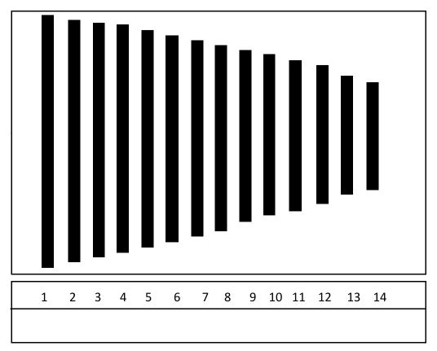
Figure :1. The key structure of gyil in two octaves.

The gyil keys are made from hardwood, arranged from lowest to highest, and are attached to a wooden frame. Sometimes they are also hung from a frame using string (traditionally made from skin). Each key is strung above a resonator (traditionally made from calabash). The calabash hangs sequentially and are tuned tothe tone of each key under which they hang that generally, the bigger calabash, the lower tone, and vice versa.
The gyil is usually played in pairs, accompanied by a calabash gourd drum called a kuor. The playing is done with a pair of rubber-headed wooden mallets. It can be played by one person as a solo instrument, as an accompanying instrument for a vocalist, or as part of an ensemble. One of its important social roles is the accompaniment of dances. At times, xylophones can be found at the court of kings, accompanying griots who sing the praises of the king and recount the past history of the kingdom; in other instances, the instrument may be played solely for the entertainment of the king. It is not possible, however, to distinguish the instrument as a typical court instrument. For Dagara people, gyil functions as a traditional music for funerals -- it is played in duets that generally consist oftwo men.
Like in Africa, in Indonesia different music occuring in different locations can sometimes bear the same name. For examples, gambang is a xylophone instrument that appears in Java and Bali. Gambang appeared in approximately the 11th century A.D., during the reign of Erlangga --the king of Bali and East-Java of the years 1019-1042. Evidence of the instrument is also found in the reliefs of Chandi Panataran—a large temple in east Java. This temple was established in the fourteenth century during the Majapahit kingdom.
In Java, the gambang keys are made from wood, while in Bali, the slabs are made from bamboo. In Jaap Kunst’s “Hindu –Javanese Musical Instruments” he outlines the relationship of musical instrument between Java and Bali including gambang, which belongs to the Hindu period. Although, Javanese and Balinese gambang have thes same name, they have different function. In Java, gambang becomes part of Javanese gamelan ensemble that consists of many kinds of instruments. This ensemble functions to accompany wayang (shadow Puppet Theater), dance performance, and social celebrations. In Bali, gambang plays a central role in ceremonial Balinese life.
In addition, the Balinese gambang has aunique ordewring of keys. The keys of Javanese gambang are structured sequentially from lowest to highest tones, like what occurs in African xylophones. However, the Balinese gambang keys are not arranged sequentially (see figure 2).
Balinese gambang uses a heptatonic scale. An esemble consists of four xylophones –made of bamboo, and two saron – metallophones. Each xylophone has adifferent name : pangenter, pemero, penyelat, and pemetit. They also have different orders of keys. Each xylophone consists of fourteen keys and two octaves. The saron has seven keys in just one octave. In the xylophone, the keys are suspended from rope (traditionally made from leather fibers). Each instrument is played by one player who uses two “Y” shaped mallets. The end of each mallet is spherical-shaped and symmetrical, made from soft wood. The music is played at a steady tempo, and involves playing separate melodies with each hand, as well as incorporates a variety of interlocking figuration (called kotekan). Right and left hand strike in irregular alternation, creating rhythmic interlocking figuration with the patterns of other players. Saron keys are arranged on the case. This instrument plays the main melody (called the pokok), at a steady tempo, and providing pressure of melodic phrase. This instrument is usually played alone, however, sometimes is played by two musicians.

10 11 12 3 4 5 6 7 8 9 13 14 1 2
a ĕ u A Ě U a o’ i o a o’’ I O

Figure 2. The key structure of gambang pengenter.

As show in this figure, the numbers of tones in an octave consist of seven as shown in number: 1,2,3,4,5,6,7, and the other number; 8,9,10,11,12,13,14 are the series of repeated for the upper octave. Basing the keys sequence as shown in figure 2, the Balinese names are, from the left notes to the right :dang, deng, dung--dAng, dEng, dUng, dAng, dong, ding, dong,-- dang, dong, --dIng, dOng. The termswhich are used capital letter refer to lower notes. Saron consist of seven keys that arraged : 7, 1,2,3,4,5,6 (I O A E U a o’ –dIng, dOng, dAng, dEng, dUng, dang, dong).
Gambang is classified as a rare ensemble that is found several villages around of Bali such as: Sempidi, Tumbak Bayuh, Kerobokan, Kedampal—Badung (Center Bali), Tenganan, Bungaya, Asak, Bugbug, Selat, Talibeng, Tihing Tali, Timrah—Karangasem (East Bali), Singapadu, Saba, Blahbatuh, Celuk, Perangsada—Gianyar (Southeast), Kesiut, Antasari, Bajera, Buruan, Kerambitan—Tabanan (Northwest Bali), and Sudaji, Jineng Dalem, Alas Angker, Padang Bulia –Buleleng (North Bali). Gambang is used mainly in cremation ceremonies. It is also functions in the temple, especially in some villages such as Sempidi and Tumbak Bayuh. In the performance it also accompanies kidung –traditional chant.
The relationship among African and Indonesia occurred in appoximately 500 A.D. A.M. Jones stated that “Indonesians certainly came to Madagascar and almost certainly to East Africa coast. The ship-rigging and canoe-forms suggest Indonesian influence on the Gulf of Guinea, and same dovetail dug-outs suggest their possible influence also in the Congo Basin”. The interaction and acculturation between both of them has appeared in many aspects included in music. For instance, some scholars revealed that African xylophoneshave been influenced byIndonesian xylophones. The African xylophone is closely paralleled with Indonesian gambang, even the whole musical systems are similar such as the tuning, the technique of playing, and the modal transposition. This is a truism.
Most African music scholars that have researched the relationship of Africa and Indonesia through the xylophone have focused their study on the history, form, tuning system, performance, and culture of the instrument. Unfortunately, indigenous aspects of its construction are ignored. From my perspective, it is important, because comparing the process of construction reinforces an assumption of their relationship. In addition, the function of music in performance practice and the restriction in gender of who play the music should be considered.
I would like to compare the function and the restriction in gender of the gyil and gambang. As I mentioned above, in Dagara, gyil functions as a traditional music for funerals – although most African music has been used for funerals. This music is devoted to the spirit of people who have passed away and travel to nirvana. In the performance, woman never plays the gyil, except as a singer. The gambang functions as traditional music for cremation ceremonies. It attends to the soul of people who have passed away and journey to nirvana. The music is addressed to people who have left -- they are given fortitude and sincerity. Gambang is always played by men.
In both of cases gyil and gambang occupy an important role in their community. Even in Bali, gambang is a sacred ensemble. Gambang is treated as a special instrument, its own repertory of sacred music, and its traditional role in rites and ceremonies. The Balinese believe that gambang has certain power to protect their village. Even the musicians should be purified with certain ceremonies before playing instruments to maintain the sanctity of gambang. For this reason, they never allow female musicians, because, generally, female musicians menstruate, which is thought to defile the sanctity of gambang.

The Tuning Systems of Gyil and Gambang
Some African music scholars whom focused their study on tuning systems of xylophones found the distinction of interval range and pitch that occurred in almost each group or village in Africa. Jones reveals that in Africa, there are almost as many differing scales as there are tribes. In addition, Kubik stated that in the Kiganda musical system there is nothing like a concept of minor thirds as opposed to seconds, but musicians have in mind, instead, a standard interval thatmay be tuned wider or smaller and is still considered to be the same interval. Frederic Viosin asserted that more than a hundred different tuning systems and re-tunings made by the musicians of different communities of the Central African Republic.
These statements show that there is no standardized tuning in African xylophones, as also found in gyil. Most Western-trained musicians often perceive the the Ghanian gyil xylophone notes in terms of a pentatonic scale, they imagine that they hear something like C,D,E,G A or C,D,F,G,B’ ect. Their opinion is very reasonable considering most of the gyil xylophones are tuned with different interval in an octave.
A similar phenomenon can be found in the gambang. Almost all Balinese music ensembles vary in tuning, such as Gong Kebyar, Angklung, SemarPagulingan, ect. Therefore, there is also no standardized tuning and there is no absolute pitch.
As I mentioned above, gambang is a heptatonic instrument that consists of seven notes per octave. Thus, there are six intervals in an octave. Collin McPhee (1966) has measured the two ensembles gambang;Kerobokan-Badung and Sukawati Gianyar. He adjusted the gambang Kerobokan-Badung to western staff notation, dIng is equal toC#,dOng is D#,dAng is E, dEng is F#, dUng is G, dang is A, and dong is A#. While, the gambangSukawati-Gianyar comprises of: dIng is equal to C, dOng is D, dAng is Db, dEng is F, dUng is G, dang is Ab, and dong is Bb. In addition, he also found different intervals among both of them.

(Insert figure 3)
Figure 3. The measurement of African xylopone and gambang.

The Construction Process ofGyil and Gambang
In this part I would like to compare the construction process Gyil and Gambanginstruments. I divide the constructionprocess into three parts; preparation, forming, and tuning. These parts are based on a chronological arrangement.
The preparation consists of several activities as shown in the list below:

Activities | African Gyil Xylophone | Balinese Gambang
Selection of materials | - Hardwood (e.g. mahogany, liga).  - The wood must be old that is marked by peeling bark and brownish. | - Petung (a kind of bamboo) in large size,hardskin, and thick fibers.  - Instrument maker usually chooses a petung that grows in a higher land.
Logging | - Dry season is a good time to logging the tree.  - Instrument maker prays before begin to hew down the tree. This is a ritual of “asking permission” to the spirit who spiritually lives in the tree. | - Logging is done by selecting a good day that is based on the Balinese calendar system; it usually happens around August to September.  - Carpenter offers the offerings before he starts to hew down.
Drying | The wood keys are dried by grilling on the furnace for two days. | - The bamboos are dried under the sun.  - It is also dried on the furnace for two months.

Figure 4. Table preparation part activites.

After the preparation process is completed, the next step is forming the keys and cases. The instrument maker begins to create the bigest or longest key. This process is continued until the smallest key is created. Then the cases are formed. The size of each of the cases is depends on the size and number of keys. Special carvings are often added to the case of Gambang instruments of Bali.

The TuningMethod ofGyiland Gambang

In Africa, the activity of tuning musical instruments is called Kukeleka. Its term is from the Mbwela/ Nkhangala language of Buganda. For instance, kukeleka chisanzi means “to tune the chisanzi”. In Bali, the term that refers to tuning musical instrument is called melaras. The term of melaras is derived from the word “laras” which means scale and its prefix “me” means action . Thus, melaras means "to tune of scale". For example, melaras gambang means “to tune the gambang”.
Based on my brief research project of the xylophoneof Ghana (gyil) and Bali(gambang), the ways of tuning these xylophonse often includes three interrelated steps. It begins with creating the intended pitches, followed by harmonizing them, and then providing the resonator for each of the pitches.
In creating the different pitches of these xylophones, the tuner usually follows the way of creating the lower and the higher pitches, that is, the length and thickness of the key defines the register of the pitches. For example, in order to get a higher pitch, the material has to be thicker when compare to the other keys, or it has to be shorter compared to the other. The process of making the lower pitch keys is the oposite of the process of making the higher ones. I believe that this is a basic principal guideline in the process of tuning the keys of xylophones.
In practice, there are two techniques for creating the high pitch, but there is only one to create the low pitch. In creating the higher pitches, the maker usually removes the lower end part of the key or by cutting [both or one of] the edges of the key (h 1 and h2). In creating the lower pitches, the bottom or upper middle part of the key is gradually removed (l 1 and l 2). (see figure 5).
h 1
l 1
h2
l 2

Figure 4. The tuning technique.

After all of the pitches have been created, the next step is tuning them; the distance between each of the keys should match the traditional scale system. This step also includes the process of harmonizing each of the keys in a different octave.
The second is how to provide an appropriate resonator for each of the keys. In Ghana, resonators are made of calabash of different sizes. The selected calabashes are tuned to the same notes suspended above them. In Bali, resonators are made either from bamboo or wood. Particularly for gambang, the resonators are made of wood and also function as the case of the xylophone. It is shaped like a rectangular box, in which on the top surface of the box (where the keys are suspended), the same numbers of holes are made that correspond to all of the pitches of the keys suspended above it. The lower the pitch uses the smaller holes and the higher the pitches, the larger ones.

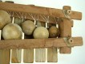

Figure 6.The form of resonator.
After the resonators are set, all of the keys are then suspended on top of their paired-resonators. The technique of suspending the keys on top of the resonators is unique. In Ghana, the keys of the Gyil are binded together using a rope. The keys of the Balinese Gambang are placed in particular positions and suspended using traditional rope (made of leather fiber). The position of the bonds (of gyil) or the holes (of gambang) is important because iteffects the vibration of the suspended keys.
There are two different ways in determining their position. The first one is by measuring the key and dividing it into four equal length. Two bonds or holes are then created on the first quarter length from both sides of the key. The second is a more advanced technique and requires deeper sensitivity and more experience as a tuner. The tuner, without measuring the key, will hold the key vertically on the predicted holes or knots, based on his sense and experience, and will hit the key in order to get the intended vibration. He will do this process several times (or maybe just once) until the right position is determined.

Figure 7.The hole position of key.

Conclusion

Based on my brief research,a comparison of the gyil and gambang, I have discovered many similarities and differences. The similarities are include the function of music in performance practice, the form of the instrument, the making and tuning process, the technique of tuning, and the phenomenon of variation in tuning. On the other hand, I also found several differences such as the scale, the material used to construct keys and resonators, and the key order.The result of this research demonstrates that the study of the relationship between Ghanian gyil and Balinese gambang, cannot be based solely on acoustical measurements and tracing history, but must also consider indigenous concepts and construction techniques.

Works Cited
Anderson, Lois. 1984. “Xylophone: General, Africa, Southeast Asia, and Pacific" in The New Grove Dictionary of Musical Instruments. New York: Facts on File.
Jones, A.M. 1971. Africa and Indonesia.The Evidence of the Xylophone and other Musical and Cultural Factors. Netherlands: E.J.Brill, Leiden
Kartawan, I Made. 2003. “Keragaman Laras Gong Kebyar di Bali: Kajian Dalam Perspektif Budaya”. Thesis. Denpasar: UniversitasUdayana.
Kubik, Gerhard. 2010. A Theory of African Music. Chicago: The Chicago University Press.
Kunst, Jaap. 1968. Hindu-Javanese Musical Instruments. Netherlands: The Hague-Martinus Nijhoff.
McPhee, Colin. 1966. Music in Bali. New Haven and London: Yale University
Nketia, J.H. Kwabenna. 1974. The Music of Africa. New York: W.W. Norton & Company
Rai S, I Wayan. 2001. “Metode Penelitian Laras (Tuning System) MusikTradisi Nusantara: Sebuah Model” Dalam Jurnal Etnomusikologi. Yogyakarta: Masyarakat Etnomusikologi Indonesia.
The Diagram Group. 1976. Musical Instruments of The World. New York: Facts on File.
Sinti, I Wayan. 2011. Gambang. Cikal Bakal Karawitan Bali. Denpasar: TSPBOOKS
Stone, Ruth M. (ed) 2000. The Garland Handbook African Music. New York and London: Garland Publishing Inc.
_______________ 1997. Theory and Technology in African Music. New York: Routledge
Wachsmann.Klaus P. 1971. “Musical Instruments in the Kiganda Tradition and their Place in the East African Scene”, in K.P. Wachsmann (ed.), Essays on Music and History in Africa. Evanston. IL: Northwestern University Press.
Voisin, Frederic. 1994. “Musical Scales in Central Africa and Java : Modeling by Shynthesis”. Leonardo Music Journal. Vol. 4.:The MIT Press.

APPENDIX
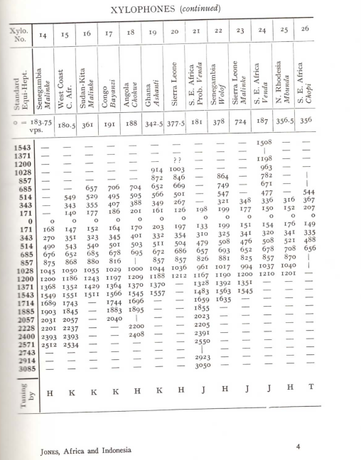

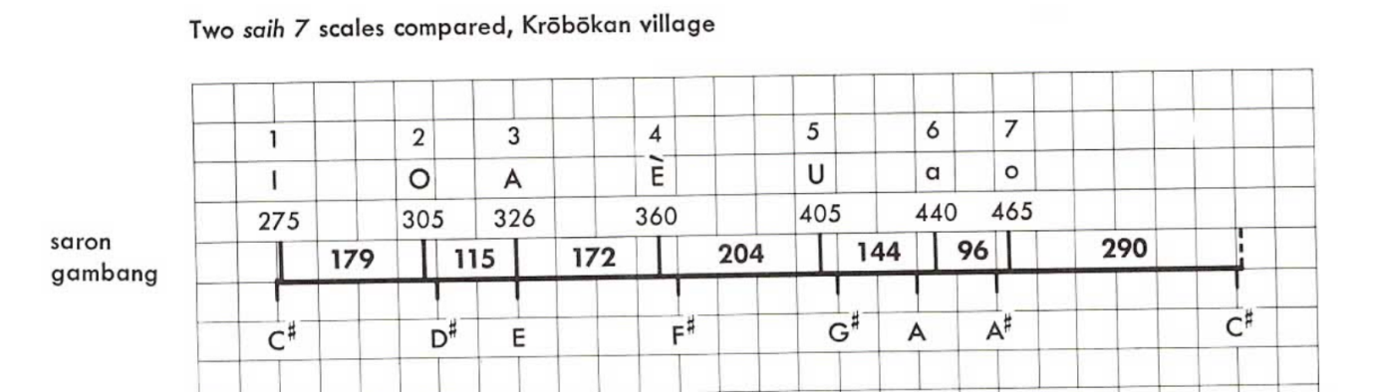
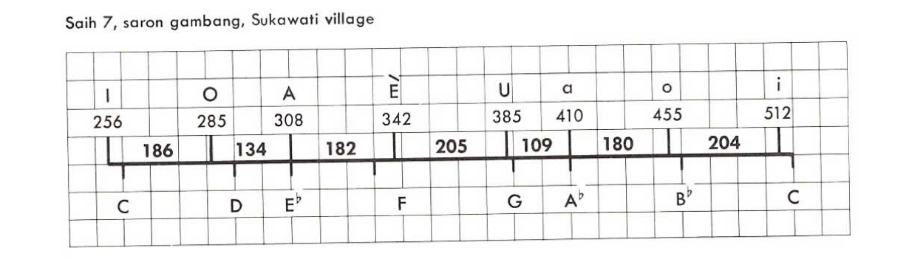
Figure 3. The measurement of African Xylophone and Balinese gambang

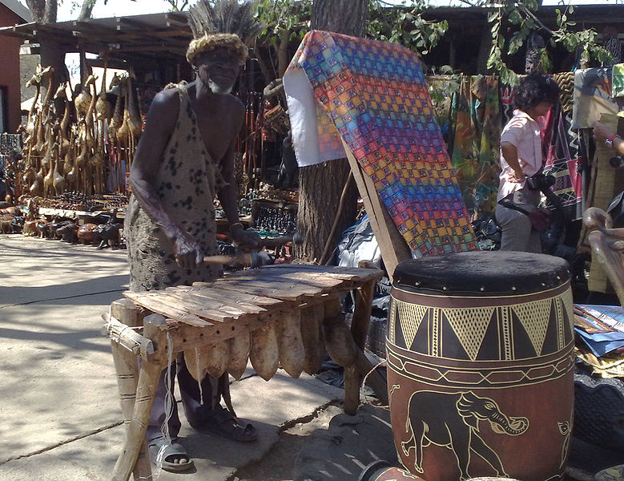
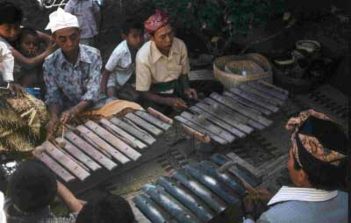

Pictures : The gyil and gambang in the performance practice.

10 11 12 3 4 5 6 7 8 9 13 14 1 2
a ĕ u A Ě U a o’ i o a o’’ I O

Figure : The key and mallet of gambang.

Figure : The key and mallet of gyil.

See J.H. Nketia, “The music of Africa” (1974, 7-8).
Soekmono, 1973:55 in I Wayan Sinti “Gambang. Cikal Bakal Karawitan Bali” (2011:4).
The name gambang itself come down to us through Old Javanese literature,e.g. several times in the Malat, the earliest date of which is late Majapahit (14th century).
See. Wayan Sinti. p.6.
See A.M Jones, 1971: 182-197.
Ibid. p. 195
See. A.M. Jones. 1971. He has measuring over 200 xylophones from Angola, from South, Central, North-central, and West Africa.
Musical Scales in Central in Central Africa and Java: Modeling by Shynthesis (p.88).
See Colin McPhee (1966).p. 272
See. Kubik. p. 393

